

**Ministry of Science and Higher Education of the Republic of Kazakhstan**

**NPJSC “Karaganda Industrial University”**

**INFORMATION LETTER**

***Dear Colleagues,***

We invite you to take part

in the XIII International Scientific and Practical Conference

**“Innovative Technologies and Engineering”**,

dedicated to the 80th anniversary of the city of Temirtau,

which will be held at **Karaganda Industrial University**

on **October 15, 2025**

|  |  |
| --- | --- |
| **Format:** hybrid (offline/online)  **Location of the event:** Karaganda Industrial University, 30 Republic Ave., Temirtau  **Working languages:** Kazakh, Russian, English. |  |

**Conference Sections**

*Section 1 – "New materials, green technologies, and innovative solutions in industry"*

*Section 2 – "Digital engineering, energy, and construction as drivers of the industry of the future"*

*Section 3 – "Knowledge economy, innovation management, and transformation of education for sustainable development"*

**Additional Information:**

Scientific research papers in the format of manuscript of no more than 5 pages are allowed to participate in the conference, corresponding to the topic of the conference and having relevant theoretical and practical significance for the development of technical, socio-humanitarian, economic sciences and information technologies. To participate in the conference, you must fill out an application for participation and attach the prepared manuscript.

Registration link: <https://forms.gle/dewNu96RZpkpWfjP7>

Deadline for submission of applications and manuscripts: **October 7, 2025** (inclusive).

Participation is **free of charge**.

The conference proceedings with ISBN will be published in electronic format after the event and posted on the official website of Karaganda Industrial University.

All authors will receive **electronic participation certificates**.

**Contact person:** Zobnin Nikolay Nikolaevich – Head of the Department of Science, Innovation and Technology Commercialization

Phone / WhatsApp: +7 701 396 5445

E-mail: [bulletin@tttu.edu.kz](mailto:bulletin@tttu.edu.kz) .

**Guidelines for Article Preparation**

* Manuscript must be carefully edited and proofread by the authors. Length of manuscript: 3–5 pages, prepared in MS Word (*.doc or *.docx).
* Font: Times New Roman, size 12, line spacing 1.0 (multiplier)
* Margins: top – 2 cm, bottom – 2 cm, left – 3 cm, right – 1.5 cm.
* Paper size: A4 (21 × 29.7 cm).
* The file name should follow the format: Surname_I.O..docx (e.g., IvanovI.I..docx).



Иванов И.И..docx

Manuscript structure:

1) The UDC is placed on the right, followed by an empty line;

2) THE TITLE OF THE ARTICLE is in capital letters, aligned in the middle, followed by an empty line;

3). Last names and initials of the author(s), – alignment in the middle, after an empty line;

4). Organization name, country, city. E-mail of the author(s), left alignment.

5) After two lines – the main text, width alignment.

Main text / [**Upload A TEMPLATE**](https://docs.google.com/document/d/1Xa-png3zdH7bjt7mCGp0h5Ok03Q_I7_g/edit?usp=sharing&ouid=111015465679010186626&rtpof=true&sd=true).

Formulas, tables, figures (color and b/w) and graphs are allowed. Formulas must be typed in the Microsoft Equation editor (**do not insert an uneditable picture**).

The figures and tables are numbered, the names (editable) of the figures are in the center, the tables are on the left, the text and numerical values in the tables (font size 12 or 10) must be editable (do not insert a picture); explanatory captions must be editable (font size 12 or 10). The labels embedded in the drawings should be carefully edited to match the drawing and the text of the abstracts. All figures, tables, and formulas in the text should be referenced.

The list of references used (title in the center), font size 12, is drawn up according to the Interstate Standard GOST 7.5-98 dated October 9, 1998 No. 365 (Protocol No. 1:3-98 dated May 28, 1998). Please observe the requirements of GOST.

The references are placed at the end of the text and typed in accordance with the order of the list. References to literature in the text are placed in "square" brackets, in the form of a number corresponding to the number of this work in the list of references. The references should include all the sources used in the text, which can be used to verify the reliability of the methods used, demonstrate awareness of previous research achievements on the topic of publication, as well as show the depth of their own research. The list should include at least 10 sources. It is advisable to avoid using sources published earlier than 8-10 years ago and limit self-citations to no more than 20 %.

The originality of the article is at least 70%.

Do not set page numbering.

**\* The article should have no more than 5 authors.**

**Шаблон для оформления статьи**

**УДК 159.964.32**

**НАЗВАНИЕ ПУБЛИКАЦИИ**

Фамилия И.О.1, Фамилия И.О.2, Фамилия И.О.3, Фамилия И.О.1,

1 Название организации, Город. Страна (E-mail:)

2 Название организации, Город. Страна (E-mail:)

3 Название организации, Город. Страна (E-mail:)

Text text text text text text text text text text text text text text text text text text text text text text text text text text text text text text text text text text text text text text text text text text text text text text text text text text text text text [1, 2-3].

$∆G= ∆H-T∙∆S$. (1)

where∆Н – enthalpy change;

T – absolute temperature;

∆Н – entropy change.

Таблица 1 – Текст текст текст текст текст текст текст текст текст текст текст текст

|  |  |  |  |  |  |  |  |
| --- | --- | --- | --- | --- | --- | --- | --- |
|  |  |  |  |  |  |  |  |
|  |  |  |  |  |  |  |  |
|  |  |  |  |  |  |  |  |
|  |  |  |  |  |  |  |  |

Text text text text text text text text text text text text text text text text text text text text text text text text text text text text text text text text text text text text text text text text text text text text text text text text text text text text text [3, 4].

Fe3O4 + CO = 3FeO + CO2 (1)

FeO + CO = Fe + CO2 (2)

FeO + C = Fe + CO (3)

Text text text text text text text text text text text text text text text text text text text text text text text text text text text text text text text text text text text text text text text text text text text text text text text text text text text text text [5].

Table 2 – Text text text text text text text text text

|  |  |  |  |  |  |  |  |
| --- | --- | --- | --- | --- | --- | --- | --- |
|  |  |  |  |  |  |  |  |
|  |  |  |  |  |  |  |  |
|  |  |  |  |  |  |  |  |
|  |  |  |  |  |  |  |  |

Text text text text text text text text text text text text text text text text text text text text text text text text text text text text text text text text text text text text text text text text text text text text text text text text text text text text text [4, 5].

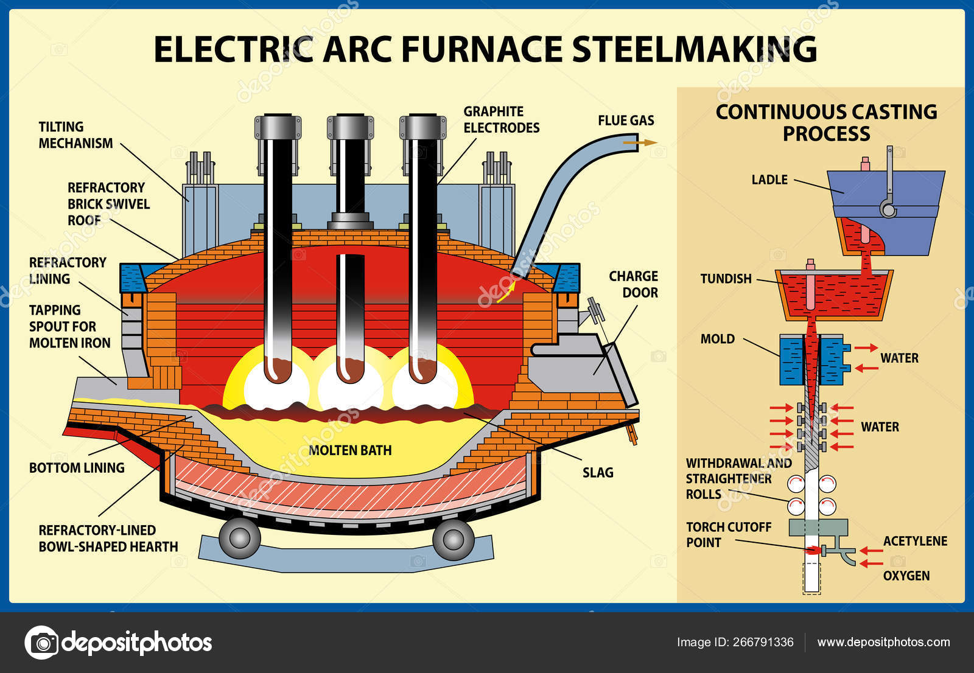

Figure 1 – Text text text

Text text text text text text text text text text text text text text text text text text text text text text text text text text text text text text text text text text text text text text text text text text text text text text text text text text text text text [5-6, 7].

**REFERENCES**

1. Literature
2. Literature
3. Literature
4. Literature
5. Literature
6. Literature
7. Literature